DATA SCIENCE AND MACHINE LEARNING
LAB CYCLE 3

Mathplotlib
Demonstrate creating various types of charts and plots using functions in mathplotlib library

- Sarah bought a new car in 2001 for $24,000. The dollar value of her car changed each year as shown in the table below.
Value of Sarah's Car
Year Value
2001 $24,000
2002 $22,500
2003 $19,700
2004 $17,500
2005 $14,500
2006 $10,000
2007 $ 5,800
Represent the following information using a line graph with following style properties
- X- axis - Year
Y –axis - Car Value
- title –Value Depreciation (left Aligned)
- Line Style dashdot and Line-color should be red
- point using * symbol with green color and size 20
Subplot() provides multiple plots in one figure.

PROGRAM:

import matplotlib.pyplot as plt
import numpy as np
xpoints = np.array([2001, 2002,2003,2004,2005,2006,2007])
ypoints = np.array([24000, 22500,19700,17500,14500,10000,5800])
plt.plot(xpoints, ypoints, '*g',ms = 20)
plt.plot(xpoints, ypoints, ':r')
leg = plt.legend(title="Value Depreciation ")
leg._legend_box.align = "left"
plt.show()

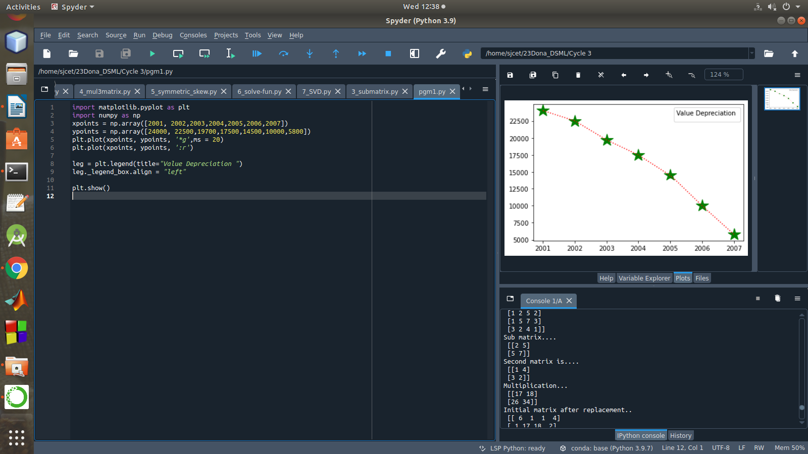

- Following table gives the daily sales of the following items in a shop
Day | Mon | Tues | Wed | Thurs | Fri
Drinks | 300 | 450 | 150 | 400 | 650
Food | 400 | 500 | 350 | 300 | 500

Use subplot function to draw the line graphs with grids(color as blue and line style dotted) for the above information as 2 separate graphs in two rows
- Properties for the Graph 1:
- X label- Days of week
- Y label-Sale of Drinks
- Title-Sales Data1 (right aligned)
- Line –dotted with cyan color
- Points- hexagon shape with color magenta and outline black

- Properties for the Graph 2:
- X label- Days of Week
- Y label-Sale of Food
- Title-Sales Data2 ( center aligned)
- Line –dashed with yellow color
- Points- diamond shape with color green and outline red

PROGRAM:

import matplotlib.pyplot as plt
import numpy as np

#plot 1:
x = np.array(['mon', 'tue', 'wed', 'thur','fri'])
y = np.array([300, 450, 150, 400,65])

plt.subplot(1, 2, 1)

plt.title("Sales Data1")
plt.xlabel("Days of week")
plt.ylabel("Sale of Drinks")
plt.plot(x,y,':c')
plt.plot(x,y,'Hm',mec = 'k')

plt.grid(color = 'blue', linestyle = 'dotted')
#plot 2:
c = np.array(['mon', 'tue', 'wed', 'thur','fri'])
v = np.array([400, 500, 350, 300,500])
plt.subplot(1, 2, 2)
plt.title("Sales Data2")
plt.xlabel("Days of Week")
plt.ylabel("Sale of Food")

plt.plot(c,v,'--y')
plt.plot(c,v,'Dg',mec = 'r')

plt.grid(color = 'blue', linestyle = 'dotted')
plt.show()

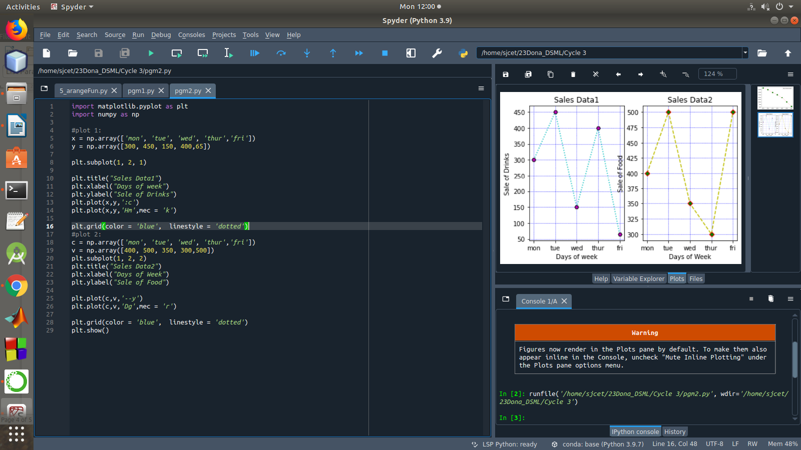

- Create scatter plot for the below data:(use Scatter function)
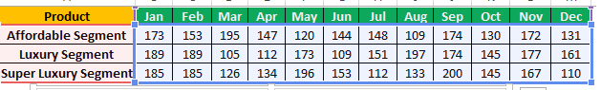

Create scatter plot for each Segment with following properties within one graph
- X Label- Months of Year with font size 18
- Y-Label- Sales of Segments
- Title –Sales Data
- Color for Affordable segment- pink
- Color for Luxury Segment- Yellow
- Color for Super luxury segment-blue

PROGRAM:

import matplotlib.pyplot as plt
import numpy as np

plt.title("Sales Data")
plt.xlabel("Months of Year")
plt.ylabel("Sales of Segments")

x = np.array([173,153,195,147,120,144,148,109,174,130,172,131])
y = np.array([173,153,195,147,120,144,148,109,174,130,172,131])
plt.scatter(x,y, color = 'hotpink')

x = np.array([185,185,126,134,196,153,112,133,200,145,167,110])
y = np.array([185,185,126,134,196,153,112,133,200,145,167,110])
plt.scatter(x,y, color = 'yellow')

x = np.array([185,185,126,134,196,153,112,133,200,145,167,110])
y = np.array([185,185,126,134,196,153,112,133,200,145,167,110])
plt.scatter(x,y, color = 'blue')

plt.show()

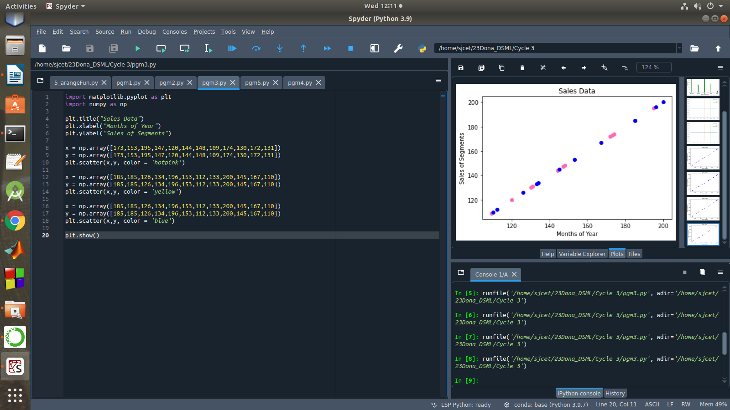

- Display the above data using multiline plot( 3 different lines in same graph)
Display the description of the graph in upper right corner(use legend())
Use different colors and line styles for 3 different lines

PROGRAM:

import matplotlib.pyplot as plt
import numpy as np

x = [1,2,3,4,5]
y = [3,3,3,3,3]
z = [4,4,4,4,4]

plt.plot(x, y, label = "line 1")
plt.plot(y, x, label = "line 2")
plt.plot(z, x, label = "line 3")
plt.legend()
plt.show()

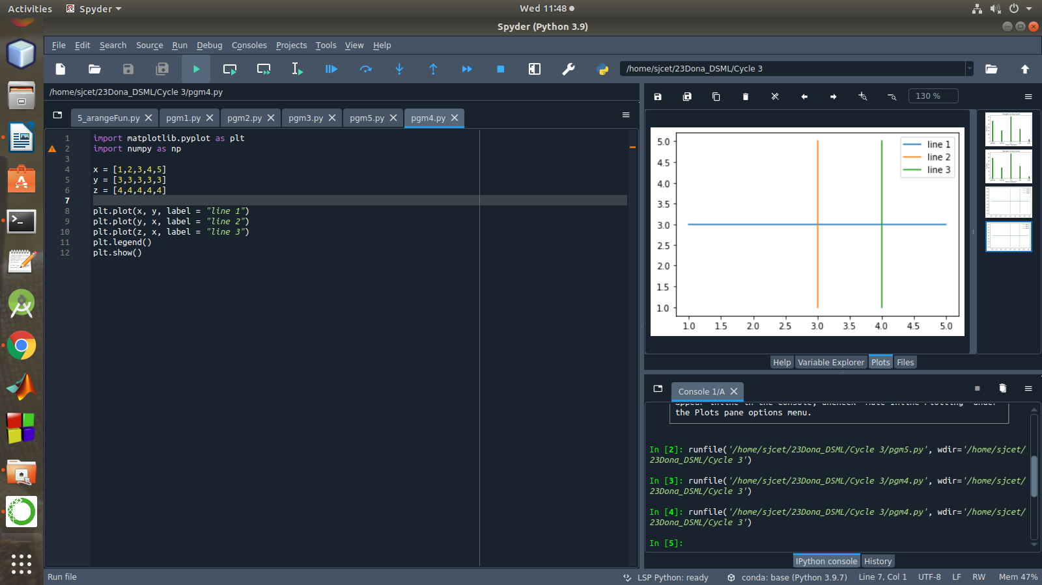

- 100 students were asked what their primary mode of transport for getting to school was. The results of this survey are recorded in the table below. Construct a bar graph representing this information.

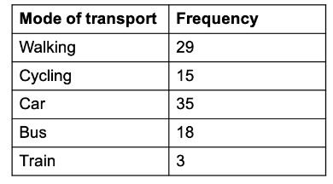

Create a bar graph with
- X axis -mode of Transport and Y axis ‘frequency’
- Provide appropriate labels and title
- Width .1, color green

PROGRAM:

import matplotlib.pyplot as plt
import numpy as np
x = np.array(["walking", "cycling", "car", "bus", "train"])
y = np.array([29, 15, 35, 18, 3])
plt.title("Transport survey record")
plt.xlabel("Mode of Transport")
plt.ylabel("Frequency")

plt.bar(x, y,color = "green", width = 0.1)
plt.show()

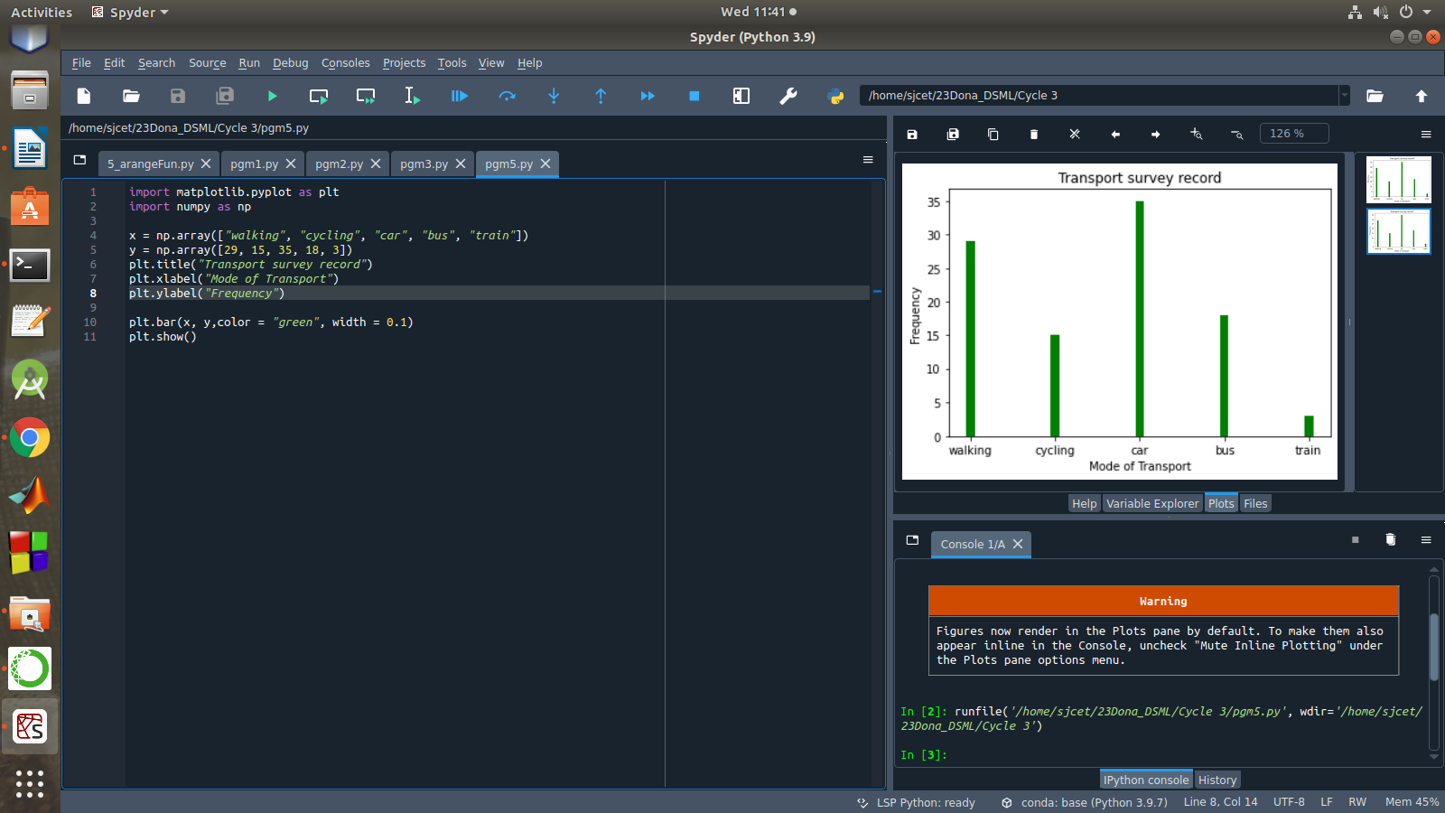

- We are provided with the height of 30 cherry trees.
The height of the trees (in inches): 61, 63, 64, 66, 68, 69, 71, 71.5, 72, 72.5, 73, 73.5, 74, 74.5, 76, 76.2, 76.5, 77, 77.5, 78, 78.5, 79, 79.2, 80, 81, 82, 83, 84, 85, 87.
Create a histogram with a bin size of 5

PROGRAM:

import matplotlib.pyplot as plt
height = [61,63,64,66,68,69,71,71.5,72,72.5,73,73.5,74,74.5,76,
76.2,76.5,77,77.5,78,78.5,79,79.2,80,81,82,83,84,85,87]
plt.hist(height, edgecolor='red', bins=5)
plt.show()

